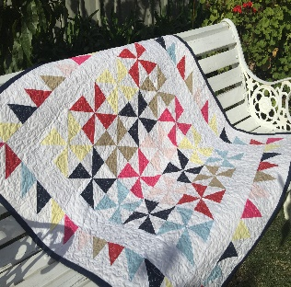
This Photo by Unknown Author is licensed under CC BY-SA-NC
CARING QUILTS
Lap size quilts for critically ill/hospitalized patients
Distributed to several critical care hospitals

- Fabrics should be classic/traditional ‘quilt’ weight fabrics for adults. Comics or child prints should not be used. ‘Quiet’ fabrics are preferred.
- Tied fleece quilts are acceptable.
- The final quilt size should be approximately 38-40 inches x 50-54 inches.
- It does not need to be made of complex blocks or complex quilting
- Delivery of the quilts (bound or unbound) should be delivered to Linda Baker. Contact 317-979-7185 or communityservice@indyasg.org to arrange pick-up.

